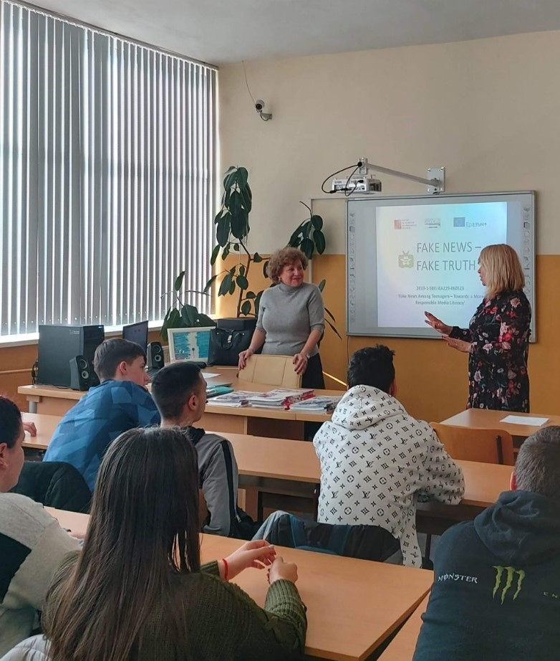
In February we organized a round table - the event was dedicated to the problem of the rising wave of fake news in the Bulgarian media, with the participation of a journalist from the national quality newspaper ‘24 Hours ’ Ms. Antoaneta Maskrachka along with a highly qualified advertiser and PR specialist Ms. Snezhana Stoimenova.
Together with the students from 9th and 10th grade, the guests discussed the phenomenon of ‘fake news’, the main reasons and mechanisms of their appearance and spread. The students showed great interest, asked many questions, to which they received competent answers from experienced professionals.

