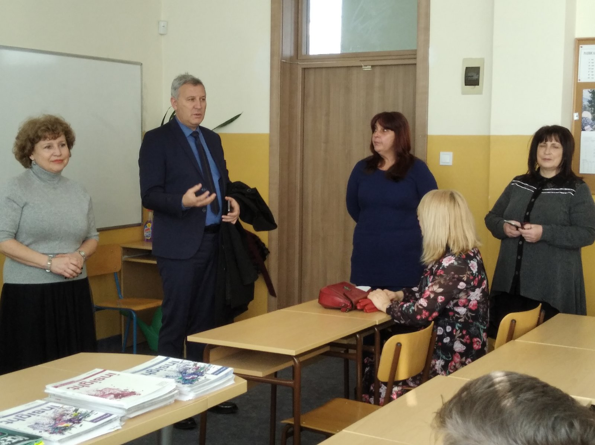
The meeting was attended by the Mayor of Razlog Mr. Krassimir Gerchev. He especially emphasized that the recognition of fake news and propaganda content is a problem among a large part of the Bulgarian youth, they need additional training and upgrading their knowledge in terms of reliable and true content, as well as acquiring skills to deal with information in news sites and social networks.

